Hope in a clay stove
In Malawi, where more than 90% of the population uses firewood for cooking, sustainable projects are developing with stoves that are more ecologically and health friendly.
BY JAVIER DOMINGUEZ REGUERO (Originally in Spanish); 28 April 2014
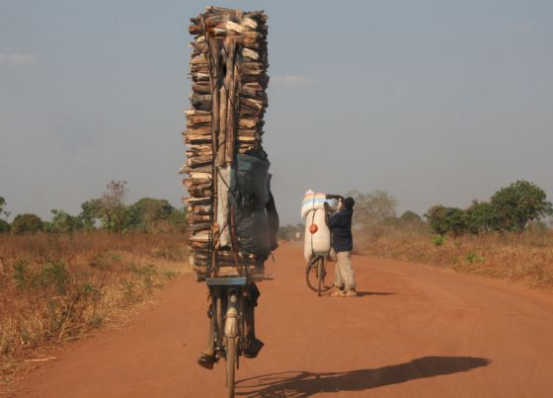
Young man carrying Wood on his bicycle in Malawi. / MAGDALENA KROHN
Driving through Malawi, it is common to see bicycles crowded with stacks of wood that are magically mounted on the back. You can barely see them heavily pedaling. Others push bicycles with sacks of charcoal strategically placed to balance the weight. However, the most common image is that of women carrying large bundles of firewood on their heads. Accompanied by their children, they walk along the road back home after a journey in search of the firewood that enables them to prepare food.
Ninety-seven percent of people in Malawi use solid fuels to cook, wood being the most common one. According to data from the National Bureau of Statistics, the population is growing at a steady rate and it is expected that the southern African country will have more than 20 million inhabitants by the end of the decade. This rate of population growth and continued reliance use on firewood will worsen the degradation of the four million hectares of forest remaining in Malawi. “The majority of the population is not conscious of this, they only act when they notice the effect on their pocket”, explains Christa Roth, advisor of Food and Fuel Consulting.
Degradation of the forest makes it more difficult to find fuelwood, so the women have to walk longer distances to collect it and at the same time, the price is rising, which creates a vicious cycle that will be difficult to exit.
However, times are changing in the cooking customs of the country. Numerous private sector companies and non-governmental organizations like Hestian and Maeve promote the use of clay stoves whose environmental, health, and social benefits, though not fully realized, are beginning to show results. This new cooking concept has had such an impact, that Malawi’s former President, Joyce Banda, encouraged the population to reach 2 million households with sustainable stoves by 2020.

Environment, health, and economy
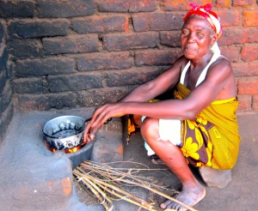
A woman using an improved cook stove. / CHRISTA ROTH
The chitetezo mbaula (or “protecting stove”, in English) are optimized stoves that have become a tool to improve the quality of life of the Malawian people. In 2004, Christa Roth in collaboration with local Malawian women designed the first prototypes of these clay stoves that “sold themselves” as the people could see how the consumption of fuelwood was considerably reduced relative to the customary method of cooking with the three stone stove.
Traditionally in Malawi, people have cooked with a rudimentary process of putting three stones in the form of a triangle over which they place a pot or pan. This is no more than cooking with an open fire that carries the risk of fires and causes the spreading of ashes. With this method, the emissions of smoke increases due to poor combustion of the wood, exacerbated when the wind blows.
The more fuelwood used, the greater the environmental impact. With the continued degradation of the forest, floods are rampant during the rainy season, which erodes the soil and compromises the landscape. The fields of crops have been stripped of their minerals and this inability to plant important food crops is a direct consequence of that affects a majority agricultural population. Further, the production and sale of coal is then taken as a possibility to generate income, contributing the yet another vicious cycle.
The Fuel Lab, directed by Pamela Jagger an Assistant Professor of Environmental Policy at the University of North Carolina at Chapel Hill has been studying, since last September, the benefits of improved cook stoves. The Fuel Lab has analyzed how the chitetezo mbaula reduces the consumption of firewood by 4%. This study offers, although preliminary, comparative data with respect to the emissions of carbon monoxide (CO) and of particulate matter, which are generally reduced by half with the use of clay stoves.
The emissions from the burning of biomass on open fires can lead to respiratory infections including pneumonia, asthma, and other negative health outcomes including pulmonary cancer. According to an analysis published in the Lancet at the end of 2012, the contamination of the air from household air pollution was the third risk factor in the Global Burden of Disease and Mortality behind only high blood pressure and tobacco consumption.
“Almost 50% of pneumonia deaths in children under 5 are due to exposure to burning fuel”, explains Dr. Deborah Havens. Havens, an expert in Internal Medicine and Environmental Medicine, works as a consultant for the CAPS research study, which tries to quantify the health benefits from improved cookstoves in Malawi. “There was a study known as ‘Respire’ in Guatemala in which they found a decline in certain health problems. But the evidence has been scarce otherwise”, said Havens.
During the last Cleaner Cooking Camp in Lilongwe, the capital of Malawi, the Fuel Lab presented fuel use and emissions results for a the Philips stove whose results are very beneficial both for the health and the environment. In any case, “this model is impossible to implement in Malawi”, said Professor Jagger in her presentation. The stove costs $90 USD, an amount that the majority cannot afford, which is why the chitetezo mbaula presents a more viable option for the country. They only cost 1000 kwachas, which is less than 2 euros, but the difference in emissions and fuel consumption are not as large as with the modern Philips stove.
The projection of an idea
There are numerous stove models throughout Africa that have joined the effort to better life conditions. “There may be as many stoves as there are circumstances”, explains Roth. Further, she noted that these stoves have to correspond with the characteristics of the acronym ‘CLEAN’: convenient, low emission, efficient, affordable, and not harmful. And the chitetezo mbaula has all of these attributes positioning itself as the most feasible stove option for Malawi.
Despite the benefits, the road has not been easy. “There needs to be political will behind the idea”, says Roth who emphasizes how the Malawian government spent many years denying the problem of biomass reliance. In Africa, more than 95% of the population uses solid fuel to generate energy and it is the only continent where the trend is still increasing. Malawi, until about two years ago, was not interested in taking action, but the perseverance of people like Christa Roth made it so that an agreement with the Global Alliance for Clean Cookstoves was finally signed.
The urban centers were hesitant at first to this process of expansion of the chitetezo mbaula. “The people were very skeptical because (the stove) is designed and more commonly used in the rural areas,” explains Maya Stewart, founder and director of Maeve. However, Stewart and her team were surprised by the overwhelming response after the marketing campaign. “Now the families that invested money in charcoal or fuelwood can devote it to food”, said Maya on the day the doors opened at Cleaner Cooking Camp.
Despite organizations like Maeve selling stoves at supermarkets and service stations, there are still many citizens that are unaware of the benefits of the chitetezo mbaula. “There are needy people in the urban zones that have to become accustomed to the techniques of the improved stoves because they still use a lot of coal and firewood”, says the Principal Secretary of the Minister of Energy, Dr. Winford Masanjala, who is in favor of reducing the dependence on fuelwood by 40%.
Thanks to these improved stoves, consuming less fuel means saving time that would be spend collecting fuelwood. By maintaining the fire in the clay pot, the cooking time is accelerated, women charged with doing the cooking and their children who usually accompany them, are provided with more security. They are also cleaner because they generate less smoke and ashes. Another of the principal advantages is that by having handles, the stoves are portable.
New stove, new horizons for women
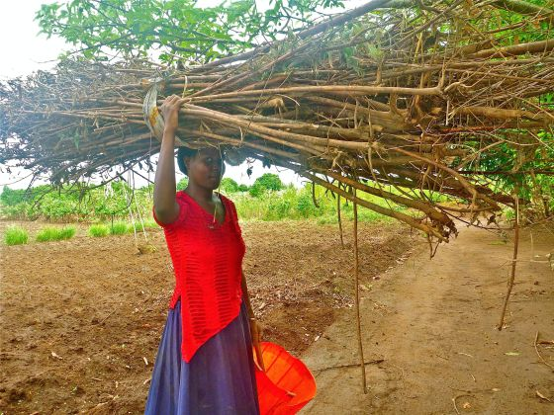
Malawian women carrying branches of pigeon pea to put in her fire at home. /CHRISTA ROTH
Since 2012, Lilongwe has hosted an annual event dedicated to evaluating the situation in the sectors of energy, food, and health to which improved cookstoves act as protagonists. Last year, the participants agreed to standardize the production of chitetezo mbaula to ensure their quality. Many have followed the example of those rudimentary stoves found with Christa Roth at the start of 2000, and applied the new standards to meet the demand.
There have been a surge of new business opportunities in a country that can make clay stoves as a local insignia because they are made from indigenous natural resources without the involvement of intermediaries or imports. It is a feasible project without many costs for those who venture to break into this new market.
Alfred Chisali, one of these entrepreneurs, owns a large center of production of chitetezo mbaula in the outskirts of Lilongwe. After entering the market, Alfred went from making 300 to 1500 stoves monthly.
The majority of the employees in these centers of production are women. Alfred has hired 14 people, the majority of whom are married to farmers. They see the chitetezo mbaula as an opportunity to become independent from men. They have embraced the business to forget hours spent collecting wood and the dangers for them and their children from cooking over an open fire. The women are in charge of the whole process: getting the clay, molding, letting the stoves dry, and at the end, they sometimes fire them. In addition, they promote and sell at all levels of trade providing them with an exciting view into the business world. Hope blooms for the women inside a culture as marked by patriarchy as Malawi.
“The women earn more than their husbands, they pay school fees and are ultimately the earners of the home”, says Roth. Thanks to this income, many families have improved their living conditions by being able to buy cattle to save on raw materials and keep their children in secondary school.
Even though there is still much to be done, only 8% of the population uses improved cook stoves, Malawi demonstrated with creativity, that using their own resources alone, they can work to decrease forest degradation, reduce deaths from respiratory infections, and be every day a society with greater gender equality.

The environmental and health impacts of traditional cooking methods in Malawi
- Percent of the population that uses solid fuels for cooking: 97%
- Population using firewood for cooking: 91.40%
- Population using dung for cooking: 0%
- Population using charcoal for cooking: 7.20%
- Population using electricity for cooking: 1.20%
- Population using improved cook stoves: 8%
- Number of persons affected by household air pollution: 15,429,289
- Number of houses affected by household air pollution: 3,588,207
- Number of infant deaths per year from household air pollution: 5,852
- Deaths per year from air pollution: 600
*Statistics from Global Alliance for Clean Cookstoves

